Lab 4: Creating, Viewing, and Editing Text Files & Using Shell Redirection, Pipes, and Variables in RHEL 9

Section 1: Save Command Output or Errors to a File with Shell Redirection
- Question: Use the ls command to list the contents of the /etc directory and redirect the output to a file named etc_list.txt.
ls /etc > etc_list.txt

- Question: Run the cat command on a non-existent file (nofile.txt) and redirect the error output to a file named error_output.txt.
cat nofile.txt 2> error_output.txt

- Question: Combine the output and error from the find command into a single file named find_results.txt, searching for any files named *.log in the /var/log directory.
find /var/log -name "*.log" &> find_results.txt

Section 2: Process Command Output Through Multiple Command-Line Programs Using Pipes
- Question: List all files in the /var/log directory, and pipe the output to the grep command to filter only for files containing "auth" in their name
ls /var/log | grep auth

- Question: Run the ps -aux command to list running processes, then pipe the output through the sort command to sort by CPU usage
ps aux | sort -nrk 3

- Question: Display all lines of a file named example.txt in uppercase using a combination of cat and tr (translate).
cat example.txt | tr '[:lower:]' '[:upper:]'

Section 3: Create and Edit Text Files Using the Vim Editor
- Question: Create a new file named notes.txt using the vim editor. Add the following text to the file and save it:
text
Copy code
Linux is a powerful operating system.
It is widely used for servers and development.

ubuntu:~$ vim dasd
ubuntu:~$ cat dasd
text
Copy code
Linux is a powerful operating system.
It is widely used for servers and development.

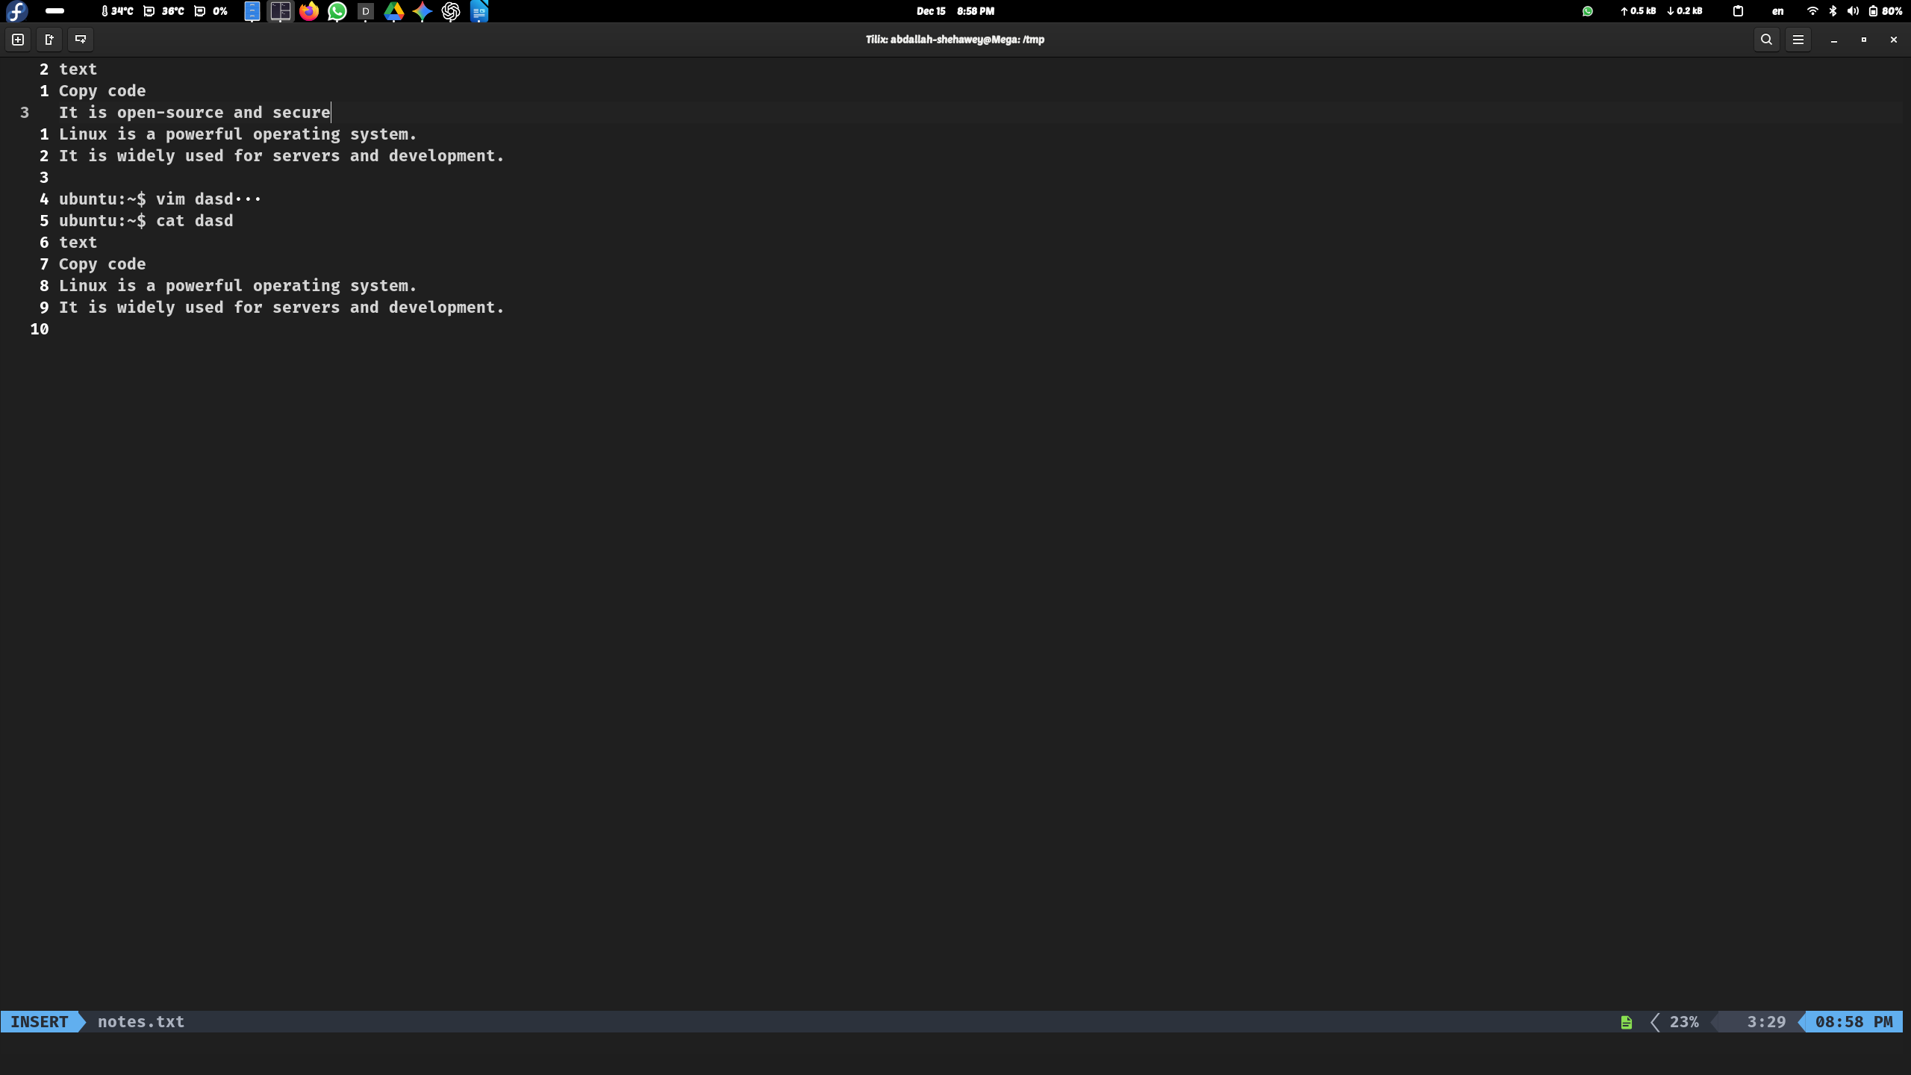
- Question: Open the notes.txt file again in vim, go to the second line, and append the text: It is open-source and secure. Save the file and exit.
- Bonus Question: In vim, search for the word "Linux" in the notes.txt file and replace it with "GNU/Linux
:%s/Linux/GNU\/Linux

Section 4: Use Shell Variables to Help Run Commands
- Question: Create a shell variable named MY_VAR and assign it the value "Hello, World!". Display the value of the variable.
MY_VAR="Hello, World!"
echo $MY_VAR
- Question: Run the command echo $HOME to display your home directory. Now assign the output of this command to a variable named MY_HOME, and use echo to display the value of MY_HOME.
MY_HOME=$(echo $HOME)
echo $MY_HOME
- Bonus Question: Use a variable named DIR_NAME to dynamically change the directory when running the cd command.
DIR_NAME=/path/to/directory
cd "$DIR_NAME"

Section 5: Edit Bash Startup Scripts to Set Shell and Environment Variables
- Question: Open your .bashrc file in vim and add a line that sets an environment variable EDITOR to vim. Save the file and restart your terminal.
vim ~/.bashrc
add this line
export EDITOR=vim
after that :wq
source ~/.bashrc
- Question: Add a new alias to your .bashrc file that allows you to run the ls -la command using just ll. Save the file and reload your shell.
alias ll='ls -la'
source ~/.bashrc
- Bonus Question:

